**HOTEL RESERVATION USING HIBERNATE AND MAVAN.**

**A PROJECT REPORT BY**

**UMA SAHINA A**

**INTRODUCTION**

**ABSTRACT:**

**FRONTEND: JAVA SPRING BOOT**

**BACKEND: MYSQL**

**Hotel Reservation System is a java spring boot and mysql which runs on a eclipse. The main feature of this project is manage rooms, Booking, Services, Hotel, Customers and Payments.**

**The major project in java using spring boot, which is suitable for my final project in edubridge learning center, the main modules of the project is Booking module , Payment module , Rooms module, Customer module and Hotel module, which performs all the operation in their respective domains. Spring Boot Project on Hotel Reservation System is secured application which run inside the JVM and we have used Eclipse IDE for developing this project.**

**For developing this Hotel Reservation System in Spring boot, we have used many of the spring boot libraries. Like for database option we have used JPA, hibernate and for writing custom queries we have used entity manager. All the dependencies of Hotel Reservation System, we are managing by pom.xml file.**

**REQUIREMENTS ANALYSIS**

**FUNCTIONLAL:**

* **Associate every online booking with an account**
* **Limit every account to a single user**
* **Enable users to search and find the most relevant booking options**
* **Accept date and time to check available rooms for that particular time**
* **Booking confirmation should be sent to the specified contact details**
* **Calculate and display accommodation charges and other utilities**
* **Cancel bookings**
* **Display and change records of guests**
* **Change rooms**

**NON-FUNCTIONAL:**

* **Use encryption to avoid bots from booking**
* **Search results should populate within acceptable time limits**
* **Users should be helped appropriately to fill in the mandatory fields, in case of invalid input**
* **System should accept payments via various payment methods**
* **Easy to use, efficient, and accessible**
* **Keep track of documentation, activities, and responses**

**UML DIAGRAM**

**UML design is the shortest form of “Unified Modelling Language”. The purpose of this**

**modelling language is to visualize the design of the system. There are total 14 types of UML**

**diagram. They are:**

**1. Class Diagram.**

**2. Component Diagram.**

**3. Deployment Diagram.**

**4. Object Diagram.**

**5. Package Diagram.**

**6. Profile Diagram.**

**7. Structure Diagram.**

**8. Use Case Diagram.**

**9. Activity Diagram.**

**10. State Machine Diagram.**

**11. Sequence Diagram.**

**12. Communication Diagram.**

**13. Interaction Overview Diagram.**

**14. Timing Diagram.**

**1. CLASS DIAGRAM:**

**This is the most used UML diagram in the field of software engineering design. It is called as a**

**main building block of any object oriented solution. Usually it illustrates the classes in a system,**

**attributes and operations of each class and also the relationship between each class.**

**Below is the “*CLASS DIAGRAM*” of our new proposed system.**

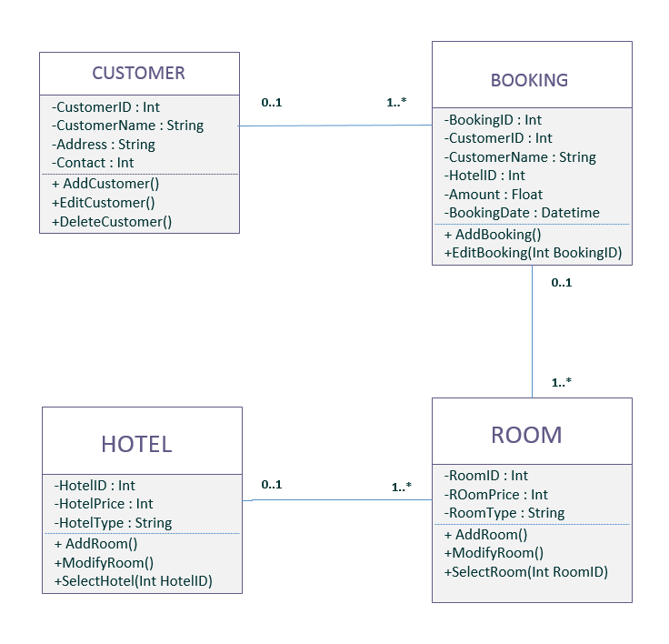

**2. USE CASE DIAGRAM:**

**It is also called behavioral UML diagram. It gives a graphic over-view of the actors involved in a**

**system directly. It shows how different functions needed by the actors how they are interacted.**

**Below is the “*USE CASE DIAGRAM*” of our new proposed system.**

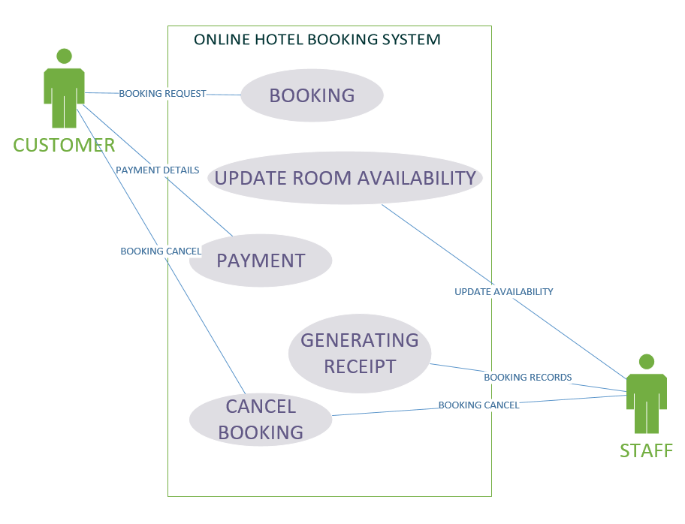

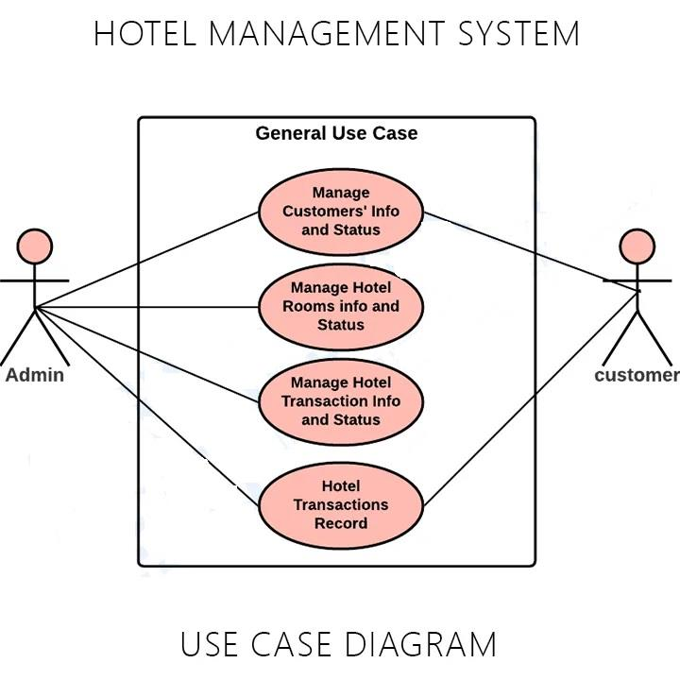

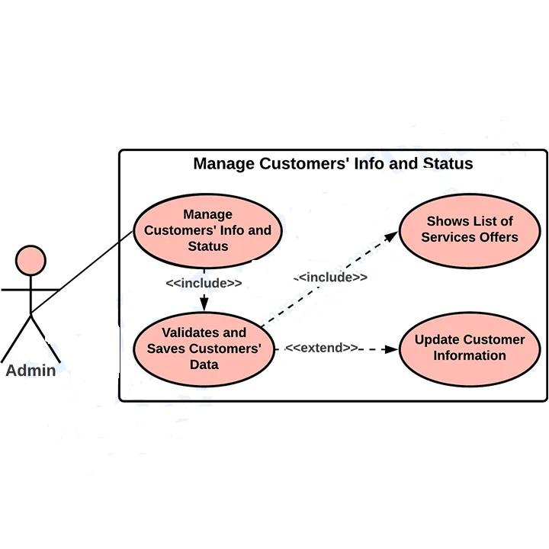

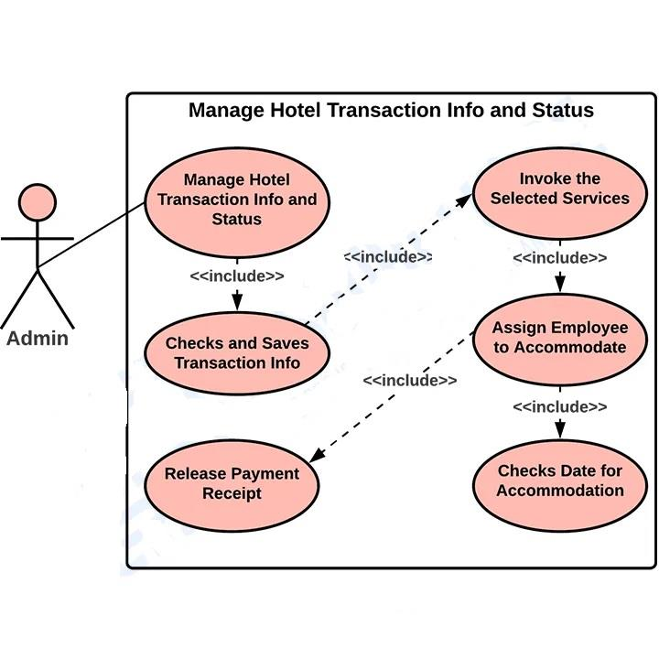

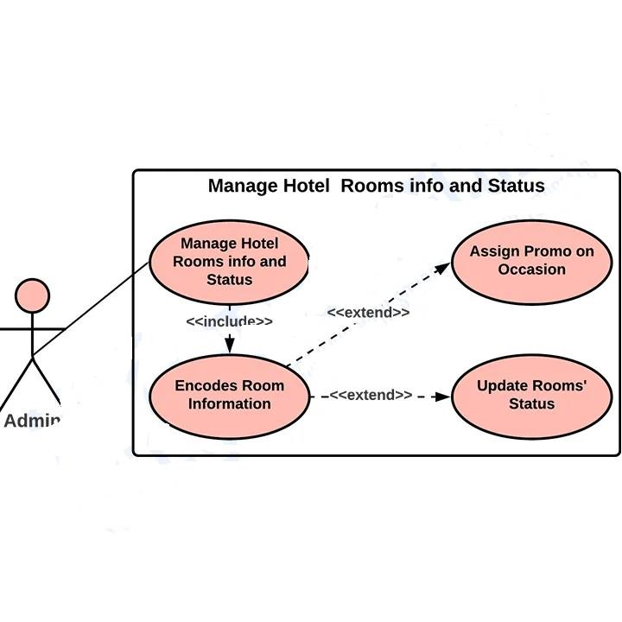

**MODULES**

**1.Entities**

**2.Exceptions**

**3.Repository**

**4.Service**

**1.ENTITIES:**

**TEST PLAN**

***Test Case 001:***

* **Test Title: Eazy Booking Icon**
* **Test Procedures: Click on the icon.**
* **Test Data: Users need to click on the icon bar.**
* **Expected Result: It will redirect to the system home page.**

***Test Case 002:***

* **Test Title: Customer & Staff Login.**
* **Test Procedures: Type username & password.**
* **Test Data: Username & password must be in alphanumeric. Otherwise system will show error (ex. Please enter valid alphanumeric data).**
* **Expected Result: It will redirect to login page.**

***Test Case 003:***

* **Test Title: Sign Up**
* **Test Procedures: Click *sign up* page.**
* **Test Data: Input customer’s information and click on the button “*SIGN UP*”.**
* **Expected Result: It will register new customer.**

***Test Case 004***

* **Test Title: Search.**
* **Test Procedures: Type destinations name with selecting check-in and check-out.**
* **Test Data: Valid destinations name with date.**
* **Expected Result: System will search according to customer’s choice.**

***Test Case 005***

* **Test Title: Manage Booking.**
* **Test Procedures: Click on the link “*Manage Booking*”.**
* **Test Data: *Add*, *Edit*, *Del* & *Save* button.**
* **Expected Result: Staffs can edit, add and Del individual customers booking records.**

***Test Case 006:***

* **Test Title: Username & Password**
* **Test Procedures: Enter customers or staffs valid username (Upper Case and Lower Case) and password (Alphanumeric).**
* **Test Data: Invalid password will show the warning message (Please Enter Valid Password).**
* **Expected Result: The system will follow the validation pattern.**

***Test Case 007:***

* **Test Title: View Booking Cancel Button**
* **Test Procedures: Customers need to sign in and can cancel the booking when they press cancel button.**
* **Test Data: Cancel their particular booking record.**
* **Expected Result: Will cancel their booking records from database.**

***Test Case 008:***

* **Test Title: Change Search**
* **Test Procedures: Customers can change their search according to changing their check in,check out and destinations.**
* **Test Data: Click on the button “Change Search” from hotels availability page.**
* **Expected Result: Customers can select their new check in and check out date with destinations.**

**IMPLEMENTATION**

**System implementation is the most important steps in case of finalizing the approved web system. We need to justify some basic requirement (software & hardware) so that the system will**

**work without having obligation and customers dissatisfactions.**

**Software Requirement:**

**Operating System: Windows (XP, 7, 8, 8.1) or Mac OSX (Tiger, Leopard, Snow Leopard, Lion, Yosemite).**

**Web Browser: Google Chrome, Internet Explorer (ver. 8 or later), Mozilla Firefox, Safari (Mac).**

**Database Management System: MySQL, SQL Server, Microsoft Access, Oracle.**

**Web Development System: Eclipse (or)Visual Studio 2010 or later, Adobe Dreamweaver, Notepad, and Notepad++.**

**Others: .NET FRAMEWORK.**

***Hardware Requirement:***

**RAM: Minimum 1GB or higher.**

**HDD: Minimum 50 GB.**

**Processor: Intel Pentium 4 or AMD.**

**LAN: Version 1.6.6.406(For fixing up client disconnection).**

**LIMITATIONS:**

**CONCLUSION:**

**The system is having some benefits for customers too. In home page customers can put their email address or phone number for downloading the booking apps directly on their phone. The**

**application will work for both OS Platform (IOS & Android). By this customers can book by using this application. Besides, customers can also book online without registering into the system. Again, customers no need to worry for payment. But for reservation they need to key in their credit card details for verification purposes. It will not charge them promptly. So, overall this system will give the customers a better user friendly environment to book online.**